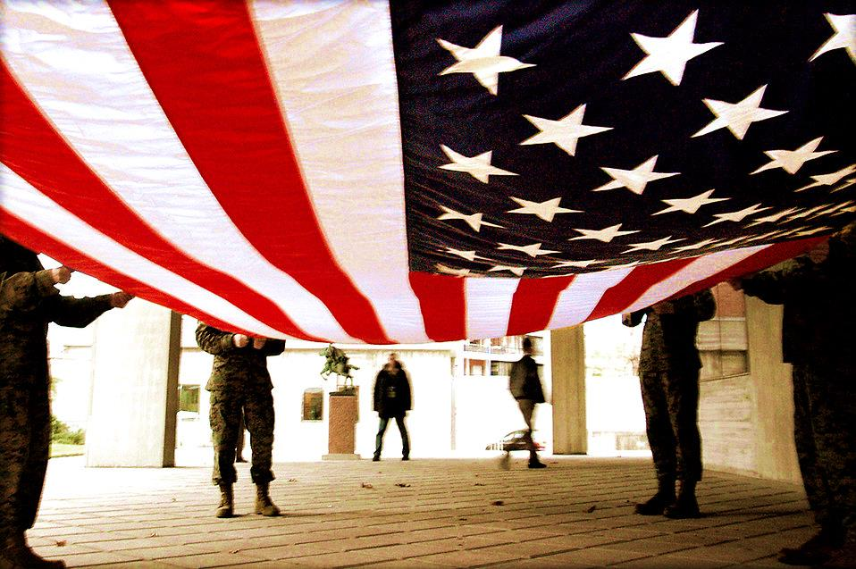
Cards for Soldiers
February 27, 2016

The Cologne, West Carver, Mayer-Watertown Dandy Lions & Legion Auxiliary are sponsoring an event for the community to give back
to the men and women serving our country.

Please join us on Saturday, February 27, 2016
From 9:00 am until done
At Cologne Academy
1221 S. Village Pkwy., Cologne, MN 55322
Complimentary lunch will be provided by the Lion’s

Our goal is to make 2000 handmade greeting cards. The cards will be mailed to Scrapping for Soldiers, an organization that will forward our cards to deployed military personnel so they can use them to send home to family members. For information on how the program works, check out their web-site at www.scrappingforsoldiers.com . If you know a service member over-seas, please bring their address so we can make sure cards are sent directly to them.

Donations are greatly appreciated and will be used to help cover the cost of postage and materials. No experience in card making is needed; there are many ways to help. All materials are cut and ready to be assembled. Please join us for a morning of sharing and caring.

If you are unable to attend but would like to donate or you have a friend or loved one you would like cards sent to, please contact:

Cologne Lions at secr.colognelions@gmail.com
Cards for Soldier’s Contest Rules
One card maybe entered into contest for a donation of 25 homemade cards and envelopes.

- Cards must be homemade cards
- Cards may not include any bling, glitter or sparkly embellishments. Embellishments of this type can be dangerous for our military members serving in the field.
- Homemade cards may be the same or different and you chose one card for each donation of 25 cards to enter into contest.
- Your cards will be donated to Soldiers Angels to be used by military members to send home to their friends or families.
- Cards must require only one 49 cent stamp (or equivalent if rates are increased) - see http://www.currentpostagerates.org/
- Cards will be judged by Cologne Leos Club based upon creativity and design.
- Please put a sticky note inside each card to be judged that includes your name, address, and phone number.
- Prizes awarded will be local gift cards from businesses in our area.
- Cards must be received on or before February 27, 2016. Cards may be brought to Cologne Academy on Feb 27 between 9:00 a.m. and noon or mailed to Paula Stephens, 313 Louis St E, Cologne, MN 55322 or dropped off art Klein Bank, Cologne MN.
- Have fun. This contest is designed to support our military members and the 5th anniversary of “Cards for Soldiers”.

