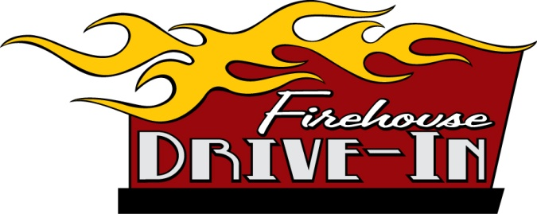

Contact: FOR IMMEDIATE RELEASE

John Hendel AUGUST 8, 2014
Phone: 952.380.8064
Jhendel405@gmail.com
www.firehousedrivein.com

FIREHOUSE DRIVE-IN 2016
SANDY, DANNY & A WHOLE LOT MORE

COLOGNE, MN…The Firehouse Drive-In is bringing Sandy, Danny and a huge cast of actors to the big screen this year as we present the 2016 outdoor drive-in movie theater many remember but few can experience. Now in its 8th year, the drive-in will be showing movies for one weekend only: August 19 & 20 at the Village Park in Cologne. Organized and put on by the Cologne Fire Department Relief Association as an annual summer fundraiser, the event offers everyone an evening or two of experiencing movies the old fashion way: in your car, under the stars and on a really BIG SCREEN. Movies will be shown on a large 50’ wide X 30’ high movie screen. The event will take place on Friday evening, August 19th and Saturday evening, August 20th.

This year we will be offering a combination of newer movies mixed with two great classics. Friday will feature: “The Good Dinosaur” and “The Breakfast Club”. The Saturday lineup includes: “Inside Out” followed by “Grease”. “When we started this event eight years ago, we weren’t sure who would attend,” stated Chuck Joos, Chief of the Cologne Fire Department. “Seeing the crowds of people who come out for one night or both has keep this event growing. We are truly grateful for the support. We have people coming that range in ag from a few months old to those who really remember the glory days of the drive-in theater”, continued Chief Joos. In addition to the movies, the audience will be treated to an 8 to 10 minute fireworks shows both evenings between the first and second movie.

- more -
The movies and fireworks are just the beginning of what you can do when you come to the Firehouse Drive-In. On both Friday and Saturday, kids will be able to enjoy a pony ride or the very popular fire truck ride. We have added face painting this year, which seems to be a very popular activity for kids. In addition there will be bounce houses and a playground to use. A fire department function would not be complete without the smoke house, offering kids an education on home fires and what to do in case of an emergency. These activities will be free for all the kids attending. The gates will open at 6 pm on Friday and Saturday with kid activities starting around 6 pm both evenings. The concession stand promises to offer you all the goodies deserving of a drive-in, come check out all the great treats. Make sure to show up early and bring your lawn chairs, blankets, radios (to listen to the movie if you are outside your car), gloves, footballs and other outdoor toys.

Parking passes are needed to reserve a spot for your car, new or old. If you bring your classic car over either evening, you will receive VIP parking in the first or second row to view the movies. On Saturday, if you drive your classic car over and park before 6:45 pm, your parking pass will require only a $15 donation. Passes can be picked up at Lenzen Chevrolet Buick in Chaska, KleinBank in Cologne and at the Holiday Station Store in Cologne. You may also get your parking pass from a Cologne Fire Department Member or Mackenthun’s in Waconia. A donation to the CFD Truck Restoration Fund will get you the pass. Plan early and get your pass for this once a year event. Parking passes are $20 each per night in advance or $25 at the gate. The donation goes towards the truck restoration and other projects funded by the Relief Association.

The Firehouse Drive-In is presented by Lenzen Chevrolet Buick of Chaska, KleinBank, Mid-County Coop and the City of Cologne. The outdoor movie experience takes place at the Village Park in Cologne which is the South West corner of Highway 212 & County Road 53. For more information, check out the website at www.firehousedrivein.com or call John Hendel at 952.380.8064.

###

